CHAPTER

# 3 Enzymes

1

*Source &Credit: Animation 3.1: Enzyme*[*pharmaxchange*](http://pharmaxchange.info/)

Enzymes are the most important group of proteins which are biologically active. They tremendously increase the eiciency of a biochemical reaction and are speciic for each type of reaction. Without these enzymes the reaction would proceed at a very slow speed making life impossible.

Enzymes are composed of hundreds of amino acids joined together and coiled upon themselves to form a globular structure. The catalytic activity is restricted to a small portion of the structure known as the active site. The reactant called substrate is attached to the active site consisting of only a few amino acids, while rest of the bulk of the amino acids maintains the globular structure of the enzyme.

Some enzymes consist solely of proteins. Others also have a non-protein part known as a **co-factor**, which is essential for the proper functioning of the enzymes. The cofactor usually acts as “bridge” between the enzyme and its substrate, often it contributes directly to the chemical reactions which bring about catalysis. Sometimes the co-factor provides a source of chemical energy, helping to drive reactions which would otherwise be diicult or impossible. Some enzymes use metal ions as co-factors like Mg2+, Fe2+, Cu2+, Zn2+ etc. The detachable co-factor is known as an activator if it is an inorganic ion (Fig. 3.1).

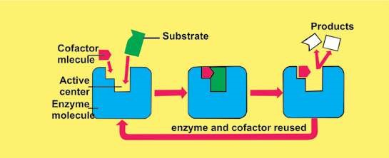

*Fig. 3.1 Substrate molecules will not it correctly at the active centre and there will be no catalytic action unless the cofactor molecule is also present*

If the non-protein part is covalently bonded, it is known as a **prosthetic group**. If it is loosely attached to the protein part, it is known as **coenzyme**. It is closely related to vitamins, which represent the essential raw materials from which coenzymes are made. Only small quantities of vitamins are needed because, like enzymes, co-enzyme can be used again and again. An enzyme with its coenzyme, or prosthetic group, removed is designated as **apoenzyme**. Adding the correct concentrated coenzyme to the apoenzyme will restore enzyme activity. An activated enzyme consisting of polypeptide chain and a cofactor is known as **holoenzyme.**

Many enzymes are simply dissolved in the cytoplasm. Other enzymes are tightly bound to certain subcellular organelles. They are produced by living cells for use in or near the site of their production. The enzymes important in photosynthesis are found in the chloroplasts and enzymes involved in cellular respiration are found in the mitochondria. Some of the enzymes which are involved in the synthesis of proteins are integral part of ribosomes.

*Animated 3.2: Enzymes*

*Source and Credit:*

*dynamicscienc*

[*e*](http://www.dynamicscience.com.au/tester/solutions1/biology/enzymes.html)

## CHARACTERISTICS OF ENZYMES

Enzymes, the biochemical catalysts possess the following important characteristics.

1. All enzymes are globular proteins.
2. They increase the rate of reaction without themselves being used up.
3. Their presence does not afect the nature or properties of end products.
4. Small amounts of an enzyme can accelerate chemical reactions.
5. They are very speciic in their action; a single enzyme Some enzymes are potentially damaging catalyzes only a single chemical reaction or a group if they are manufactured in their active of related reactions. form. For example, **pepsin** is a powerful
6. They are sensitive to even a minor change in pH, protein - digesting enzyme and is quite temperature and substrate concentration. capable of destroying cell’s internal 7. Some enzymes require a co-factor for their proper structure and thus is produced in functioning. inactive **pepsinogen** form by the cell. It

8. They lower the activation energy of the reactions. is converted in its active form only in the digestive tract where it is required to be

## MECHANISM OF ENZYME ACTION active. (CATALYSIS)

An enzyme is a three dimensional globular protein that has speciic chemical composition due to its component amino acids and a speciic shape. Every enzyme by virtue of its speciicity recognizes and reacts with a special chemical substance called substrate. Any enzyme, therefore, reacts only with its speciic substrate and transforms it into product(s). It is then released unaltered and thus can be used again and again.

E + S m ES m E + P Enzyme Substrate Enzyme Enzyme Product substrate complex

*Animated 3.3: Catalysis*

*Source and Credit:* [*promma.ac.th*](http://www.promma.ac.th/main/chem_online/Chapter14/CH14_14.6_Main.html)

In certain cases enzymes act in a series of chemical reactions in a particular order to complete a metabolic pathway such as respiration or photosynthesis. The successive enzymes containing these reactions are normally present together in a precise order of reaction such that substrate molecules can be literally handed on from one enzyme to another forming a enzyme to enzyme chain. In this way, the products from one step in pathway are transferred to the enzyme catalyzing the next step.

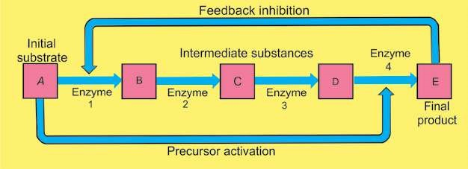

*Fig, 3.2 Enzyme to enzyme chain (association)*

*Animated 3.4: Enzyme to enzyme chain*

*(association)*

*Source and Credit:* [*faculty.ccbcmd*](http://faculty.ccbcmd.edu/courses/bio141/lecguide/unit7/genetics/protsyn/regulation/noncom.html)

An enzyme and its substrate react with each other through a deinite charge-bearing site of an enzyme called active site. The charge and shape of the active site is formed by some amino acids present in the polypeptide chain of the active site of the enzyme. These amino acids are brought closer and are arranged in a speciic way by coiling and folding of the polypeptide chain within the globular symmetry of the enzyme (Fig. 3.3).

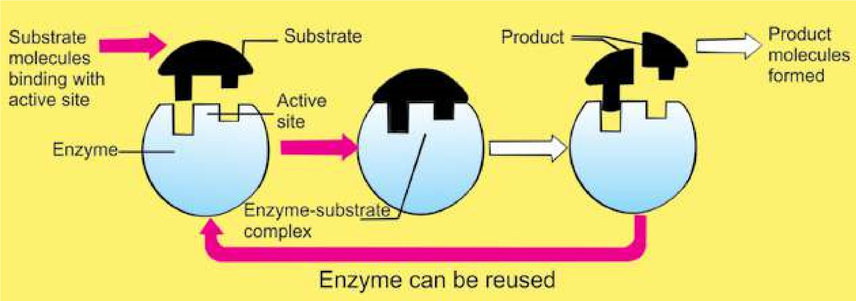

*Fig. 3.3 Diagrammatic representation of an enzyme-substrate reaction (Lock and Key Model)*

The active site of the enzyme is made up of two deinite regions i.e the binding site and the catalytic site. The binding site helps the enzyme in the recognition and binding of a proper substrate to produce an ES complex. This reaction activates the catalytic site. Activated catalytic site catalyzes the transformation of the substrate into product(s). Thus the enzyme after catalysis detaches itself from the products unchanged. Enzyme requires aqueous medium for its activity.

Most enzymes do not loat about in a kind Emil Fischer (1890) proposed a Lock and Key model to of cytoplasmic soup’ but are attached visualize substrate and enzyme interaction. According to membrane systems inside the cell to this model, as one speciic key can open only a in speciic and orderly arrangements. speciic lock, in the same manner a speciic enzyme can Mitochondria and chloroplasts are good transform only one substrate into products(s). examples of this.

According to Lock and Key Model the active site is a rigid structure. There is no modiication or lexibility in the active site before, during or after the enzyme action and it is used only as a template.

Later studies did not support this model in all reactions.

On the basis of new evidences Koshland (1959) proposed its modiied form. This is known as Induce Fit Model.

He argued that when a substrate combines with an enzyme, it induces changes in the enzyme structure. The change in structure enables the enzyme to perform its catalytic activity more efectively.

## FACTORS AFFECTING THE RATE OF ENZYME ACTION

The functional speciicity of every enzyme is the consequence of its speciic chemistry and coniguration. Any factor that can alter the chemistry and shape of an enzyme can afect its rate of catalysis. Some of the important factors that can afect the rate of enzyme action are: concentration of enzyme, concentration of substrate, temperature, and pH of the medium.

### 1. Enzyme Concentration

The rate of reaction depends directly on the amount of enzyme present at a speciic time at unlimited substrate concentration. If the amount of enzyme is increased by two fold the reaction rate is doubled.

By increasing the enzyme molecules an increase in the number of active sites takes place. More active sites will convert the substrate molecules into product(s), in the given period of time. After a certain limiting concentration, the rate of reaction will no longer depend upon this increase.

### 2. Substrate Concentration

At low concentration of substrate the reaction rate is directly proportional to the substrate available.

If the enzyme concentration is kept constant and the amount of substrate is increased, a point is reached when a further increase in the substrate does not increase the rate of the reaction any more (Fig.3.4). This is because at high substrate level all the active sites of the enzyme are occupied and further increase in the substrate does not increase the reaction rate.

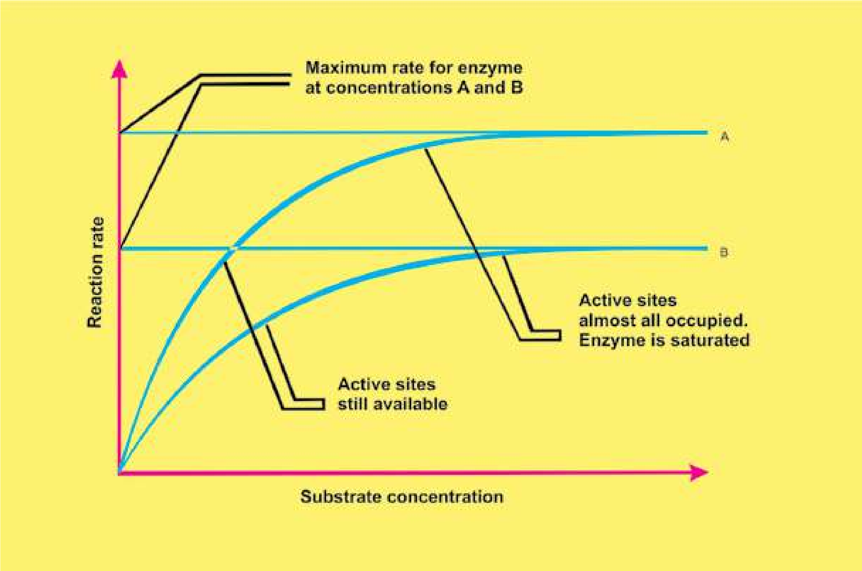

*Fig. 3.4.1 leet o f substrate c oncentration on the rate of an enzyme catalyzed reaction.*

### 3. Temperature

The rate of enzyme controlled reaction may increase with increase in temperature but up to a certain limit. All enzymes can work at their maximum rate at a speciic temperature called as optimum temperature. For enzymes of human body 37°C is the optimum temperature (Fig.3.5).

Heat provides activation energy and therefore, chemical reactions are accelerated at high temperatures. Heat also supplies kinetic energy to the reacting molecules, causing them to move rapidly. Thus the reactants move more quickly and chances of their collision with each other are increased. However, further increase in heat energy also increases the vibrations of atoms which make up the enzyme molecule. If the vibrations become too violent, globular structure essential for enzyme activity is lost and the enzyme is said to be denatured.

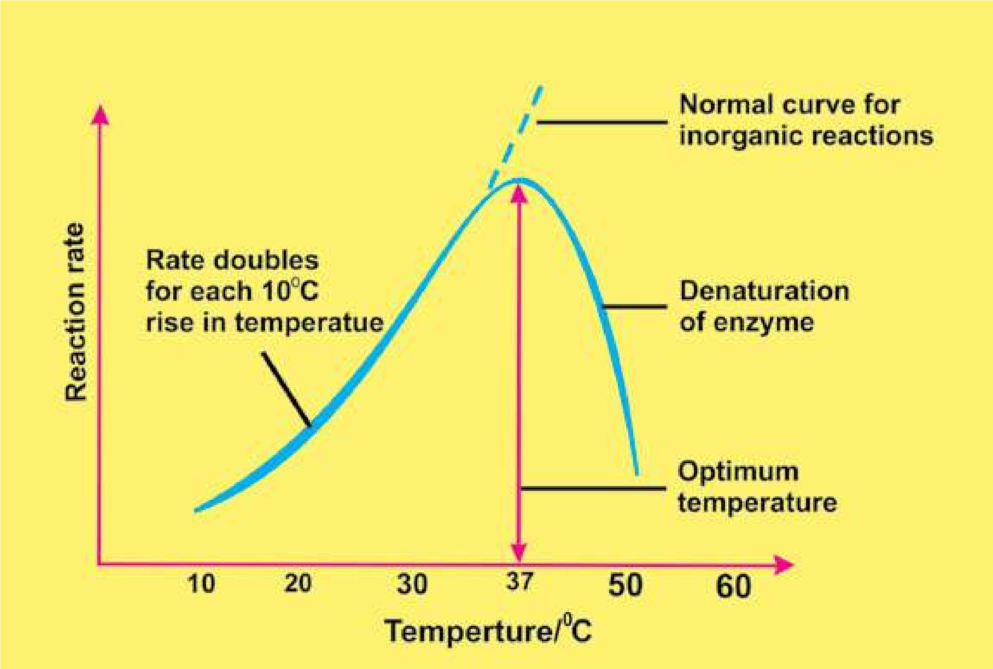

*ig.3.5. Efect of temperature on the rate of an enzyme catalyzed reaction*

### 4. pH Value

Every enzyme functions most efectively over a narrow range of pH known as the **optimum pH** as shown in Table 4.1.

A slight change in pH can change the ionization of the amino acids at the active site. Moreover, it may afect the ionization of the substrates. Under these changed conditions enzyme activity is either retarded or blocked completely.

Extreme changes in pH cause the bonds in the enzyme to break, resulting in the enzyme denaturation.

**Table 4.1 Optimum pH values for some enzymes**

|  |  |
| --- | --- |
| **Enzyme** | **Optimum pH** |
| Pepsin | 2.00 |
| Sucrase | 4.50 |
| Enterokinase | 5.50 |
| Salivary amylase | 6.80 |
| Catalase | 7.60 |
| Chymotrypsin | 7.00-8.00 |
| Pancreatic lipase | 9.00 |
| Arginase | 9.70 |

### Inhibitors

An inhibitor is a chemical substance which can react (in place of substrate) with the enzyme but is not transformed into product(s) and thus blocks the active site temporarily or permanently, for example poisons, like cyanide;, antibiotics, anti-metabolites and some drugs.

Inhibitors can be divided into two types: (i) Irreversible (ii) Reversible

#### Irreversible Inhibitors

They check the reaction rate by occupying the active sites or destroying the globular structure. They occupy the active sites by forming covalent bonds or they may physically block the active sites.

#### Reversible Inhibitors

They form weak linkages with the enzyme. Their efect can be neutralized completely or partly by an increase in the concentration of the substrate.

They are further divided into two major types: A. Competitive B. Non-competitive

#### A. Competitive Inhibitors

Because of the structural similarity with the substrate they may be selected by the binding sites, but are not able to activate the catalytic sites. Thus product(s) are not formed (Fig.3.6).

#### B. Non-competitive Inhibitors

They form enzyme inhibitor complex at a point other than the active site. They alter the structure of the enzyme in such a way that even if genuine substrate binds the active site, catalysis fails to take place.

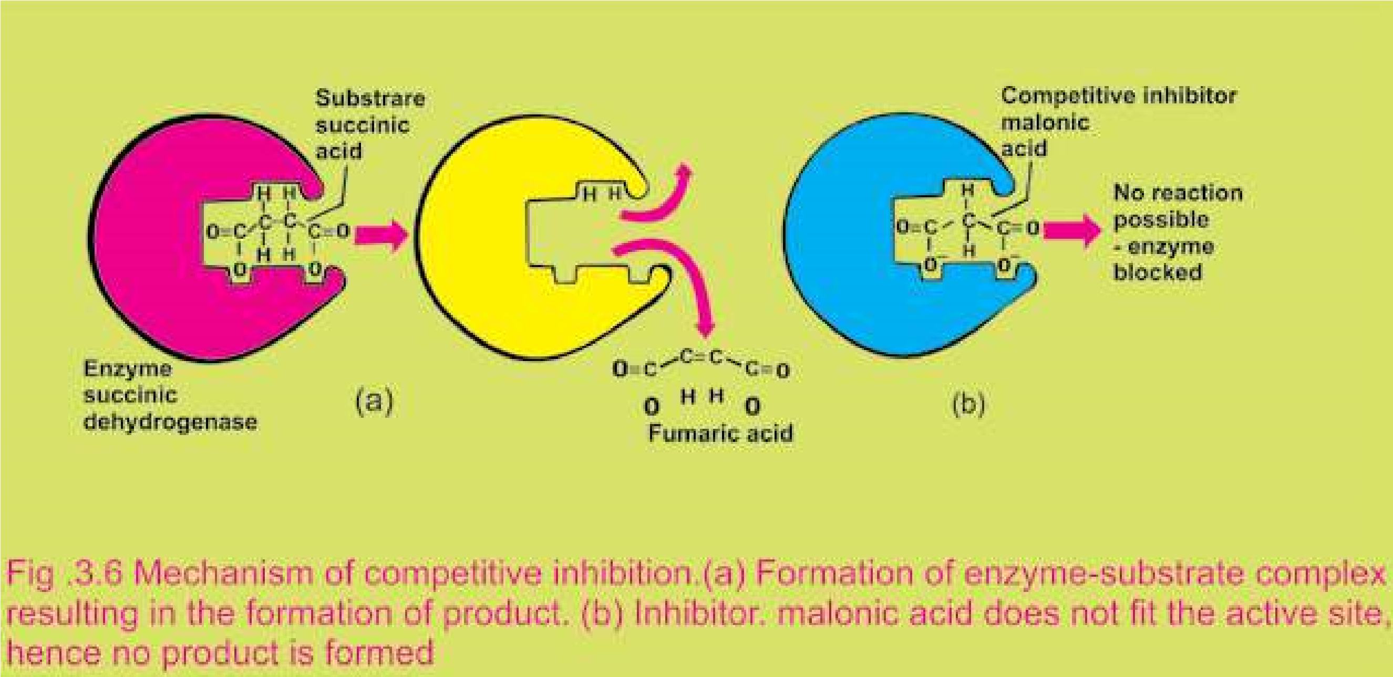

*Animated 3.5: Non-competitive Inhibitors*

*Source and Credit:* [*academic.brooklyn*](http://academic.brooklyn.cuny.edu/biology/bio4fv/page/noncomb.htm)

**Exercise**

**Q.1. Fill in the blank.**

1. Enzymes are composed of hundreds of____________
2. Some enzymes consist of a non-protein part known as a _________
3. Many enzymes require non-protein component called _________ for their proper functioning.
4. Enzymes are highly ________ in nature.
5. The enzymes which carry out the synthesis of _____________ are integral parts of ribosomes.

**Q.2. Write whether the statement is ‘true’ or ‘false’ and write the correct statement if it is false.**

(i) The enzymes important in photosynthesis are found in tire mitochondria (ii) Large amounts-of an enzyme can accelerate chemical reactions.

1. Calvin Malvin proposed Lock and Key model for enzyme action.
2. The active site of an enzyme is composed of four regions. (v) Structure of an enzyme has no speciic importance.

**Q.3. Short Questions**

1. List two conditions that destroy enzymatic activity by disrupting bonds between the atoms in an enzyme.
2. How do low and high temperature, afect an enzyme activity?
3. What is a prosthetic group?
4. Deine inhibitors of enzyme.
5. How does an enzyme accelerate a metabolic reaction?

**Q.4. Extensive questions.**

1. Describe in detail the mechanism of enzyme action.
2. Give the efect of pH and temperature on the eiciency of an enzyme action.
3. Write a note on inhibitors of enzymes.
4. What is the importance of enzymes in life?

CHAPTER

# 4 The Cell

*Animation 4.1: Plant cell*

[*Source & Credit: Wiki*](http://wiki.ggc.usg.edu/wiki/User:Eagnew:Projects3)*.gcc*

The cell can be deined as the structural and functional unit of life. It is the smallest unit that can carry out all activities of life. Cells are building blocks of complex multicellular organisms.

## EMERGENCE AND IMPLICATION OF CELL THEORY

Study of cell (cell biology) began with the discovery of cell by Robert Hooke (1665), who reported his work in his famous publication **Micrographia**. He prepared and studied thin sections of cork (of dead plant material) under his self-made compound microscope.

He observed that the cork is composed of minute honey comb like compartments which he termed as Cells (Fig.4.1). According to Hooke, cell is an empty space bounded by thick walls. Very little information was added to this idea in the following century. The work again started in the beginning of 19th century.

Lorenz Oken (1805) a German scientist , believed that “all living beings originate from or consist of vesicles or cells”. Jean Baptist de-Lamarck (1809) expressed similar idea and said “no body can have life if its constituent parts are not cellular tissue or are not formed by cellular tissue”.

Fig.4.1 The microscopic structure of a

piece of cork

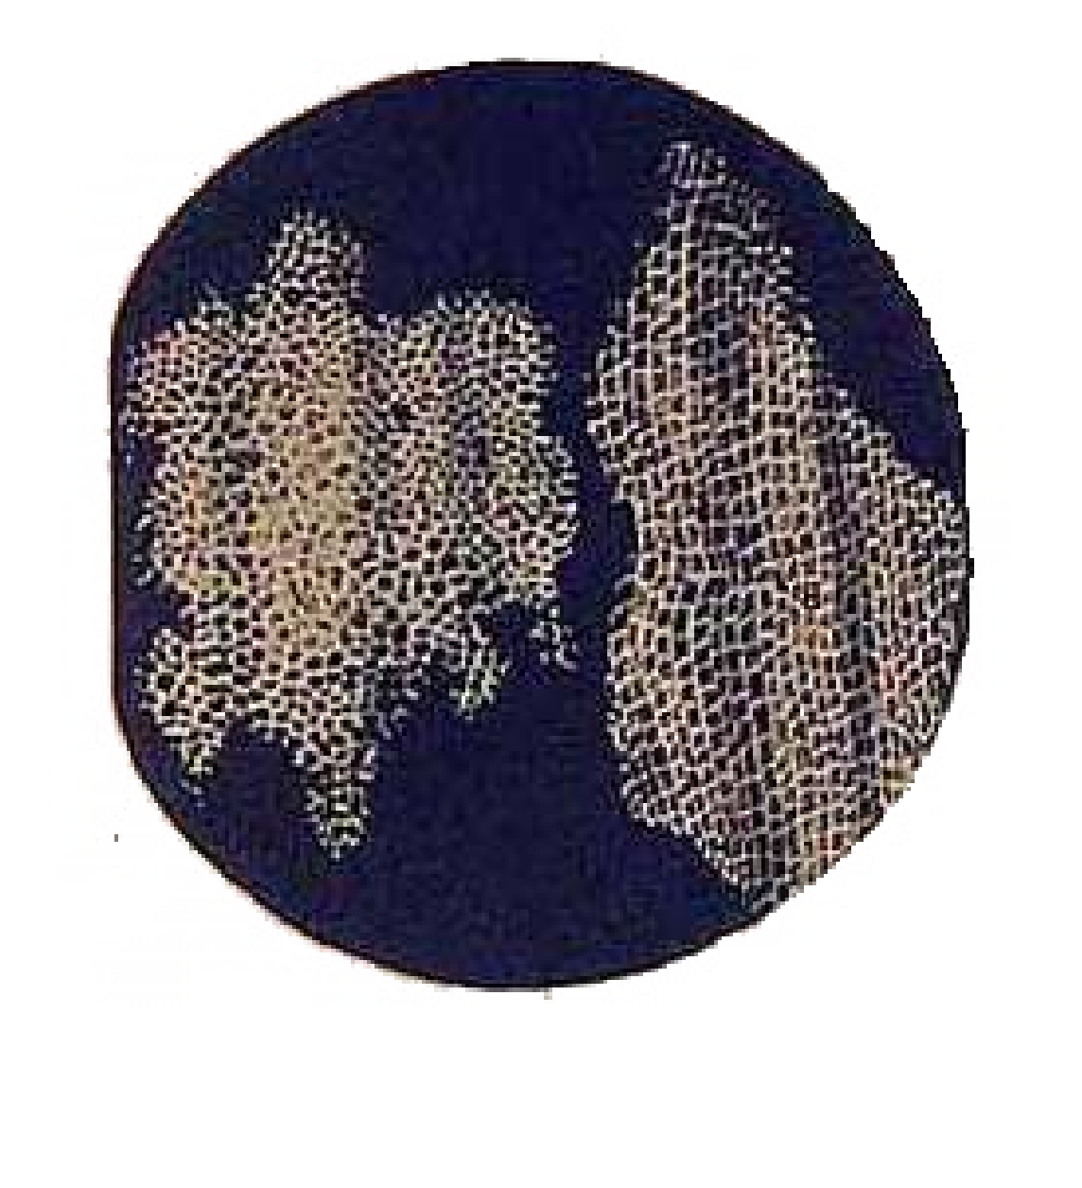

In 1831 Robert Brown reported the presence of nucleus in the cell. Due to this discovery Hooke’s idea about the cell as an empty space was changed. It was later established that cell is not an empty space. A German zoologist Theodor Schwann (1839) and a German botanist Schleiden (1838), working independently, came out with a theory called the Cell Theory.

They found that the cell consisted of 3 basic parts, viz nucleus, the luid (cytoplasm) surrounding the nucleus, and an outer thin covering or membrane (plasma membrane). The cell wall, they said, was an additional structure, present only in plant cell. Keeping in view this deinition of cell, the cells could be observed in plant as well as in animal; according to cell theory, all living organisms are composed of cells and cell products.

[The cell theory is one of the most fundamental generalizations in Biology. It has wide ranging efect in all ields of biological sciences. After the cell theory was presented, many details of cell were studied, as a result of which the cell theory was extended.](http://www.sabaq.pk/video-page.php?sid=sindh-biology-11th-4.1&v=b-the%20cell-16b)

[Rudolph Virchow (1855), a German physician, hypothesized that new cells were formed only by the division of previously existing living cells (to put it in Virchow’s words : “omnis cellula e cellula”). It was contrary to the idea of “abiogenesis” (living things arise spontaneously from nonliving things), one of the prevailing but controversial ideas about origin of life, at that time. Louis Pasteur (1862), one of the greatest scientists of all times, supplied experimental proof for Virchow’s hypothesis by demonstrating that microorganisms (bacteria) could be formed only from existing bacteria. Original cell theory and Virchow’s hypothesis gave us the basis for working deinition of living things: living things are chemical organizations composed of cells and capable of reproducing themselves’. August Weismann (1880) said ‘all presently living cells have a common origin because they have basic similarities in structure and molecules etc. It was shown that there are fundamental similarities in the chemical composition, metabolic activities and structure, although they difer in many respects. Cells are basically similar but extraordinarily versatile. Cell is not only the structural but also the functional unit of living organisms. So cell theory is a very important unifying concept](http://www.sabaq.pk/video-page.php?sid=sindh-biology-11th-4.1&v=b-the%20cell-16b)

[The human naked eye can diferentiate between two points, which are at least 1.0 mm apart. This is known as resolution of the eye. This resolution can be increased with the aid of lenses. In a typical compound microscope the resolution is 2.0 nm, which is about 500X that of naked eye. A compound microscope is a typical laboratory microscope with at least diferent magniication powers. The typical ocular lenses could be 5X and 10X, but others also exist. Likewise diferent types of objective lenses viz. 20X, 40X, 100X etc exist. The magniication power of microscope is determined by multiplying X values of ocular lense and X value of objective lense. Therefore, a microscope with 10X ocular lens and 40X objective lense will have (10X40 = 400X) 400X magnifying power. The resolution will, however, remain the same, which is 500X that of the naked eye. The source of illumination in such microscopes is visible light. In electron microscope the source of illumination is a beam of electrons and the resolution of microscope ranges between 2-4 Angstrom, which make it 500X greater than that of the compound microscope and 250,000X greater than that of the naked eye. This means that two points which are 2-4 Angstrom apart can be diferentiated with the help of electron microscope. The revelation of complexity of structure of various cellular organelles is closely linked with the development of microscopy and improvement in the resolution power of the microscope.](http://www.sabaq.pk/video-page.php?sid=sindh-biology-11th-4.1&v=b-the%20cell-16b)

The salient features of Cell Theory in its present form are:

1. All organisms are composed of one or more cells.
2. All cells arise from pre-existing cells.
3. Cell is the basic structural as well as functional unit for all organisms.

### Cell as a unit of structure and function

A cell is a unit of structure and function in living organisms. In multicellular organisms there is a division of labour among cells. Diferent cells are specialized for diferent functions. The function of the organism as a whole is the result of the sum of activities and interactions of diferent cells and of diferent components of the cell. In animals e.g., muscle cells contract and relax, nerve cells transmit impulses, gland cells secrete, red blood cells carry oxygen and some stomach cells secrete gastric juice. Similarly in plants xylem cells conduct water and mineral salts from soil to the aerial parts of the plant. Phloem cells translocate food, sclerenchymatous cells give support to the plants, chlorenchymatous cells carry out photosynthesis, parenchymatous cells store surplus food and meristematic cells produce new cells for growth and development of the plant. As they perform diferent functions they show great variation in shape and size. Despite the structural and functional diversity, the plant cells as well as animal cells have a common plan of organization.

## STRUCTURE OF A GENERALIZED CELL

Structure of a cell can be studied under light microscope as well as electron microscope. The modem technology enables us to isolate various components of cells including its organelles by a process of cell fractionation and study their structure and function in detail. During cell fractionation the tissues are homogenized or disrupted with special instruments and the various parts of the cells are separated by density gradient centrifugation. This separation is achieved by spinning the homogenized or disrupted cells in a special medium in a centrifuge at medium speed. The various cellular parts separate out in diferent layers depending upon their size and weight, and density of the medium. Some cellular components require very high speeds for separation from other parts of the cells. This is achieved through ultracentrifugation.

A cell consists of the following basic components:

1. Plasma membrane, also a cell wall in plant cell.
2. Cytoplasm, containing cell organelles.
3. Nucleus, with nuclear or chromatin material.

In the traditional system of classiication all organisms are divided into plants and animals. The cells of plants and animals can be distinguished by the presence or absence of cell wall. Cells of

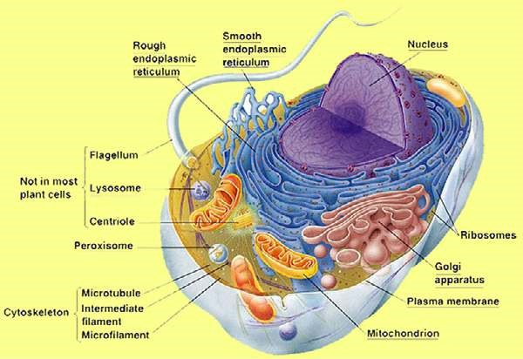

*Fig.4.2: Electron microscope structure of a animal cell.*

*Fig. 4.3 Electron microscopic structure of a plant cell*

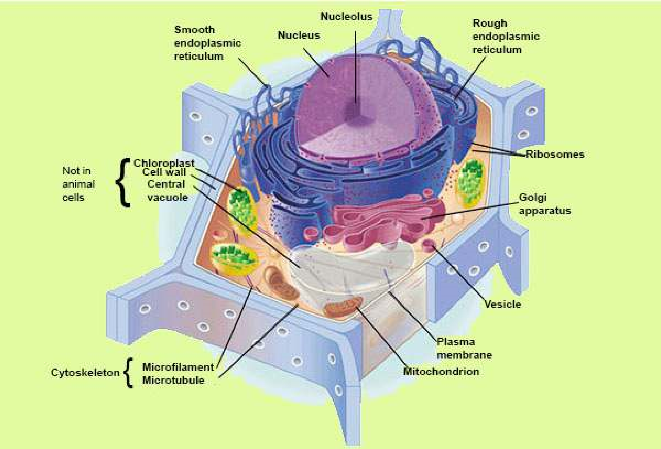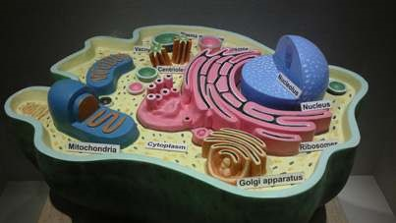

*Image 4.2: Structure of Animal Cell*

*Source and Credit: wikipedia*

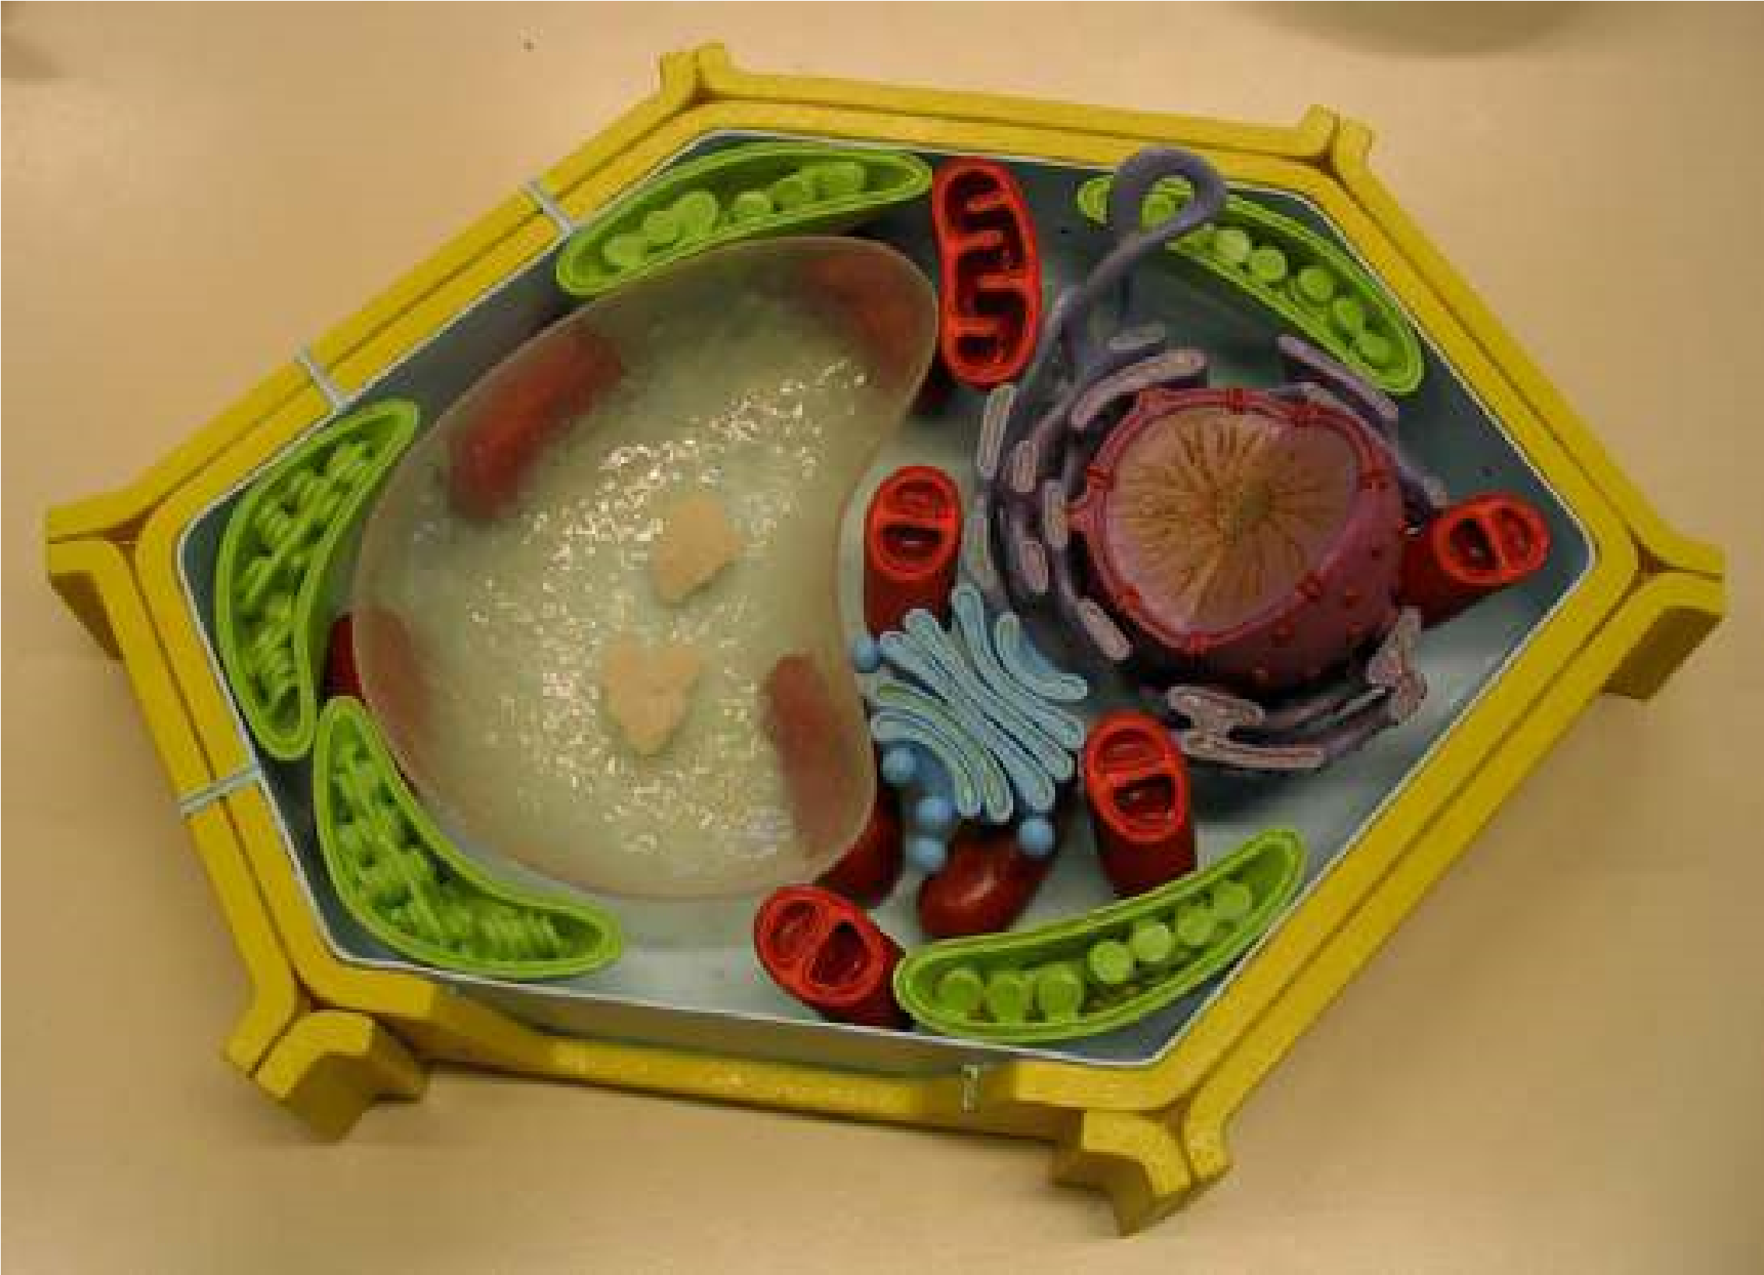

*Image 4.3: Animal Plant Cell*

*Source and Credit: thegreatestgarden*

animals and plants absence of cell wall. Cells of animals and plants are complex and have a distinct nucleus (chromatin material is bounded by a membrane) and are called Eukaryotic. On the other hand, the primitive type of cells, such as bacteria, lack a deinite nucleus and are said to be Prokaryotic. In Prokaryotes the nuclear material is directly submerged in the cytoplasm and is not separated from it by membranes.

The eukaryotic cells vary greatly in size. They could be as big as an Ostrich’s egg. Most of the cells are microscopic and are not visible to the naked eye. Their size is measured in micrometer (nm). One nm is 0.000,001 meter or 1x 10-6 of a metre.

The use of modern technology has made it possible to study the following components of the cell in detail (Fig.4.2 and 4.3).

[**Plasma Membrane**](https://vimeo.com/152387602)

[Plasma membrane or cell membrane is the outer most boundary of the cell. However, in most plant cells, it is covered by a cell wall. Cell membrane is chemically composed of lipids and proteins; 60 - 80% are proteins, while 20-40% are lipids. In addition there is a small quantity of carbohydrates.](https://vimeo.com/152387602)

[Many biologists contributed to establish the structural organization of cell membrane. It was proposed earlier that cell membrane is composed of lipid bilayer sandwiched between inner and outer layers of protein (Fig.4.4). This, basic structure is called the **unit membrane** and is present in all the cellular organelles. The modem technology has revealed that lipid bilayers are not sandwiched between two protein layers.](https://vimeo.com/152387602)

[The protein layers are not continuous and are not conined to the surface of the membrane but are embedded in lipid layers in a mosaic manner (Fig.4.5). This discovery led to the proposal of **Fluid Mosaic Model**. This model at present is the most accepted one. Cell membrane also contains charged pores through which movement of materials takes place, both by active and passive transport.](https://vimeo.com/152387602)

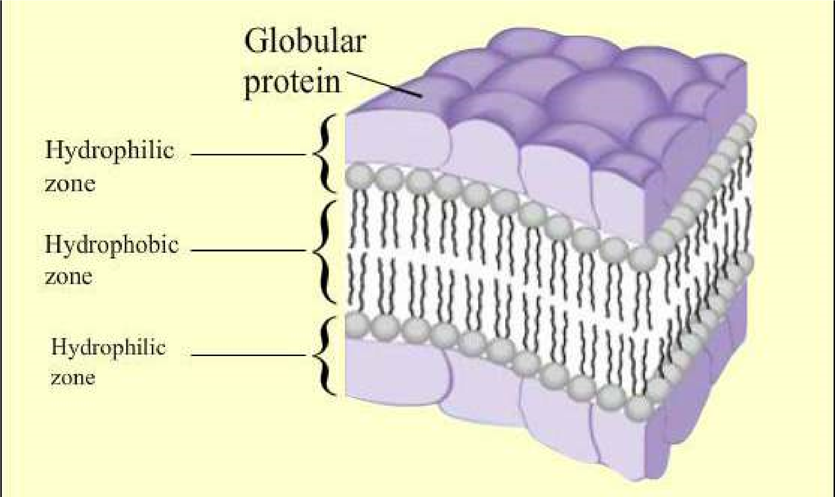

[*Fig: 4.4. Unit membrane*](https://vimeo.com/152387602)

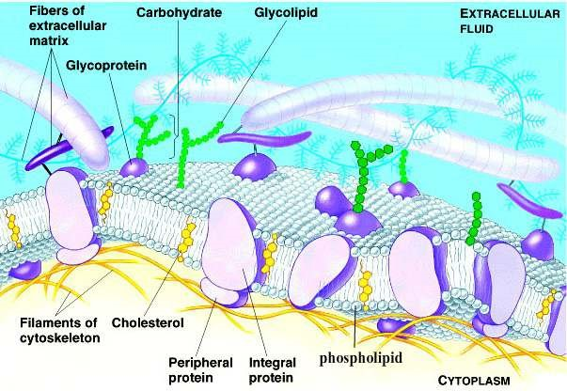

*Fig. 4.5. Fluid Mosaic Model*

Transport of materials is one of the vital roles it plays for the cell. It ofers a barrier between the cell contents and their environment, allowing only selective substances to pass through it, thus it is known as **diferentially permeable** or selectively permeable membrane. The substances which are lipid soluble cross it more easily than others, therefore, it regulates the low of materials and ions to maintain a deinite gradient. Many small gas molecules, water, glucose etc. being neutral can easily cross while ions, being charged particles, have some diiculty in crossing. Many substances which are not needed, constantly enter the cell by passive transport, others are taken up against the concentration gradient (they move from the area of low concentration to the area of high concentration). This uphill movement of materials requires energy and is termed as active transport. The energy used for this movement is provided by ATP.

In many animal cells, the cell membrane helps to take in materials by infolding in the form of vacuoles. This type of intake is termed as **endocytosis** which can be either **phagocytosis** (to engulf solid particles) or **pinocytosis** (to take in liquid material). In neurons (nerve cells) the cell membrane transmits nerve impulses from one part of the body to the other to keep coordination.

### Cell Wall

The outer most boundary in most of the plant cells is cell wall. The cell wall of plant cell is diferent from that of prokaryotes, both in structure and chemical composition. It is secreted by the protoplasm of the cell. Its thickness varies in diferent cells of the plant. It is composed of three main layers: primary wall, secondary wall and the middle lamella. The **middle lamella** is irst to be formed in between the **primary walls** of the neighbouring cells. The primary wall is composed of cellulose and some deposition of pectin and hemicelluloses. Cellulose molecules are arranged in a criss cross arrangement (Fig.4.6). The primary wall is a true wall and develops in newly growing cells. The **secondary wall** is formed on its inner surface and is comparatively thick and rigid. Chemically it is composed of inorganic salts, silica, waxes, cutin lignin etc. Prokaryotic cell wall lacks cellulose; its strengthening material is peptidoglycan or murein. Fungal cell wall contains chitin.

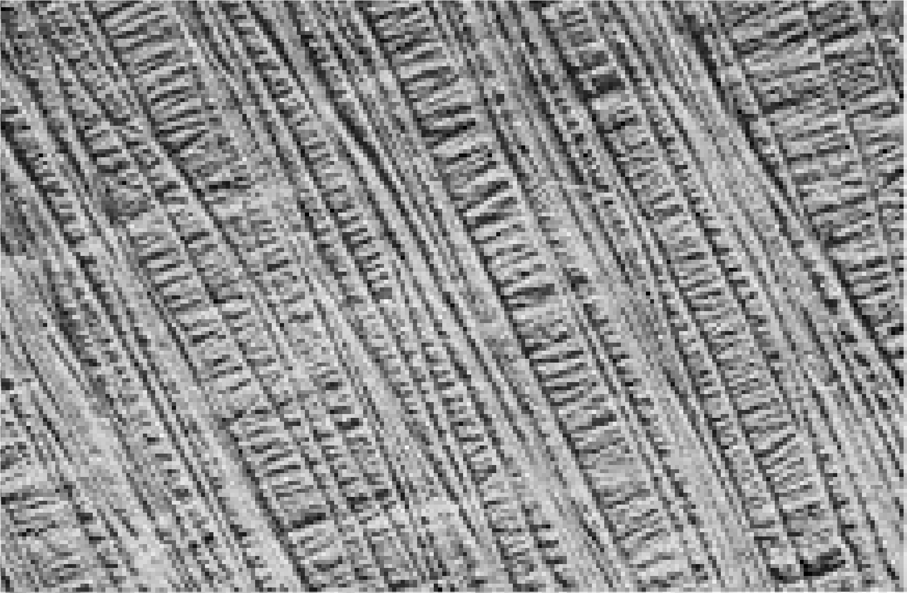

*Fig.4.6. Secret of the strength of plant structure is revealed by electron microscope photographs of the cell walls. The cellulose ibers are arranged in layers, with the ibres of each layer at right angle to those of other layers.*

Cell wall is very important. It provides a deinite shape to the cell and keeps it rigid. It does not act as a barrier to the materials passing through it.

*Animation 4.2: Cell Wall*

*Source and Credit:*

*gifsou*

[*p*](http://gifsoup.com/)

## Cytoplasm

The living contents of the eukaryotic cell are divided into nucleus and the cytoplasm, the two collectively form protoplasm. Cytoplasm consists of an aqueous ground substance containing a variety of cell organelles and other inclusions such as insoluble wastes and storage products. The soluble part of the cytoplasm is called **cytosol**. It forms the ground substance of the cytoplasm. Chemically it is about 90% water. It forms a solution containing all the fundamental molecules of life. In the cytosol, small molecules and ions may form true solutions, and some large molecules form colloidal solutions. Colloidal solution may be a **sol** (non-viscous) or a **gel** (viscous). Peripheral parts of the cell are often like a gel.

The most important function of the cytoplasm is to act as a store house of vital chemicals. It is also a site for certain metabolic processes such as glycolysis.

In living cells the cytoplasm contains several cell organelles such as endoplasmic reticulum, mitochondria, Golgi complex, nucleus, plastids, ribosomes, lysosomes and centriole. The free loating cell organelles e.g. mitochondria move about in cytoplasm due to cytoplasmic streaming movements. This is an active mass movement of cytoplasm.

### Endoplasmic Reticulum

Under an electron microscope a network of channels is seen extending throughout the cytoplasm. These channels are often continuous with plasma membrane and also appear to be in contact with the nuclear membrane. This entire system of channels is the Endoplasmic Reticulum. These membranes vary widely in appearance from cell to cell. The material present in these channels is separated from the cytoplasmic materials by the spherical or tubular membranes, called **cisternae**.

There are two morphological forms of endoplasmic reticulum; a rough form with attached ribosomes and a smooth form without ribosomes. The rough surfaced endoplasmic reticulum (RER) is involved in the synthesis of proteins. After synthesis the proteins are either stored in the cytoplasm or exported out of the cell through these channels. The smooth surfaced endoplasmic reticulum (SER) helps in metabolism of a number of diferent types of molecules particularly lipids. They also help to detoxify the harmful drugs. In some cells SER is responsible for transmission of impulses, e.g. muscle cells, nerve cells. In addition, SER also plays an important role in the transport of materials from one part of the cell to the other. Endoplasmic reticulum also provides mechanical support to the cell so that its shape is maintained.

*Animation 4.3: Rough Endoplasmic Reticulum*

*Source and Credit:*

*Ameoba sister*

[*s*](http://www.amoebasisters.com/)

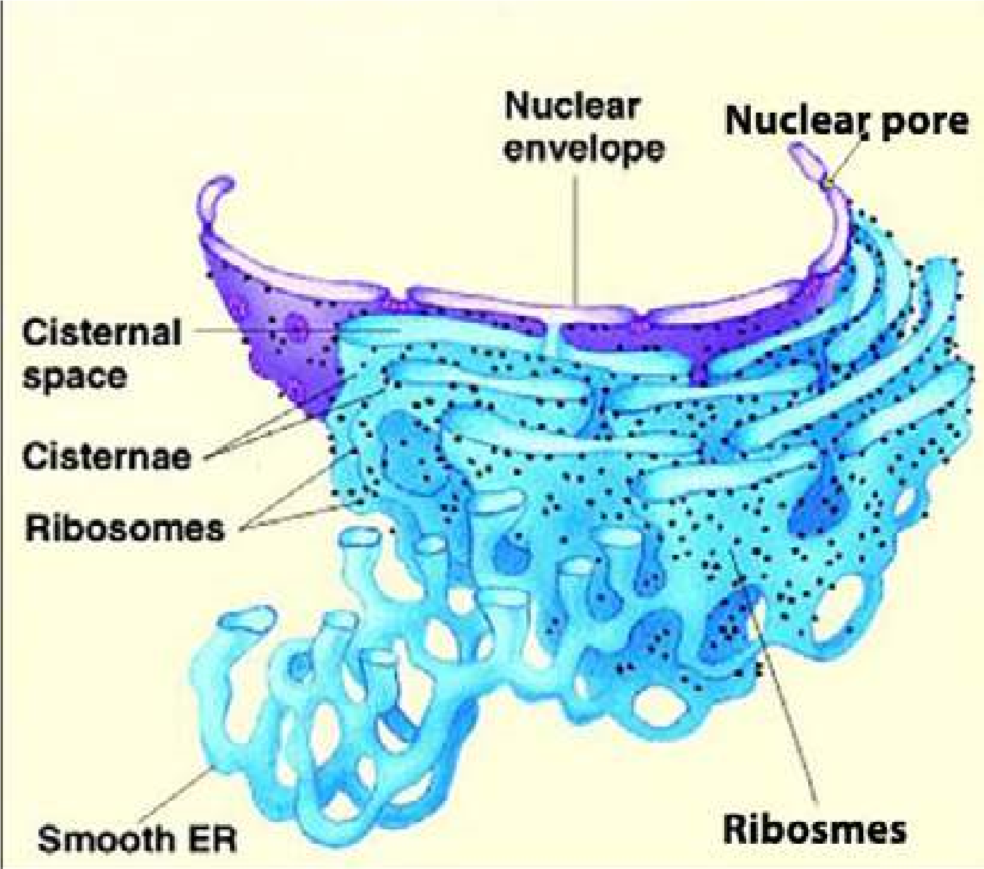

*Fig. 4.7: Rough endoplasmic reticulum is marked by the presence of ribosomes attached to the membranes of endoplasmic reticulum. Proteins synthesized on ribosomes are pushed into channels of endoplasmic reticulum, from where they are transported to Golgi Apparatus, on their way out of the cell.*

### Ribosomes

Cell contains many tiny granular structures known as ribosomes. Palade (1955) was the irst person to study them. Eukaryotic ribosomes are composed of an almost equal amount of RNA and protein, hence they are ribonucleo-proteins particles. The RNA present in ribosome is called ribosomal RNA. Ribosomes exist in two forms; either freely dispersed in cytoplasm or attached with RER as tiny granules. Each eukaryotic ribosome consists of two sub-units. The larger subunit sediments at 60S (S= Svedberg unit used in ultracentrifugation), while smaller subunit sediments at 40S. Two subunits on attachment with each other form 80S particle. This attachment is controlled by the presence of Mg2+ ions. The ribosomes are attached to messenger RNA through small ribosomal subunit. A group of ribosomes attached to mRNA is known as **polysome** (Fig. 4.8).

*Fig. 4.8 mRNA attached to ribosomes forming polysomes.*

*Animation 4.4: Ribosomes*

*Source and Credit:*

*Natur*

[*e*](http://www.nature.com/)

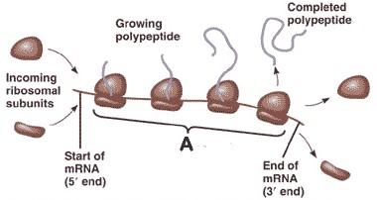

New ribosomes are assembled in the nucleolus of the nucleus from where they are transported to the cytoplasm via the pores in nuclear membrane. The factory of ribosome is the nucleolus, while that of protein synthesis is the ribosomes.

*Animation 4.5: Ribosome*

[*s*](http://www.maktab.pk/unit/fsc-biology-book1-ch-4-lec-11-ribosomes/?id=365)

*Source and Credit:*

*natu*

[*r*](http://www.nature.com/)

[*e*](http://www.nature.com/)

### Golgi Apparatus

Golgi apparatus was discovered by Golgi in 1898. This apparatus, which was found virtually in all eukaryotic cells, consists of stacks of lattened, membrane bound sacs, called cisternae. These cisternae together with associated vesicles are called Golgi complex. It is a complex system of interconnected tubules around the central stacks. Cisternae stacks are continuously formed by fusion of vesicles, which are probably derived by the budding of SER. Their outer convex surface is the forming face, while the inner concave surface is the maturing face. The cisternae break up into vesicles from the latter. The whole stack consists of a number of cisternae thought to be moving from the outer to the inner face.

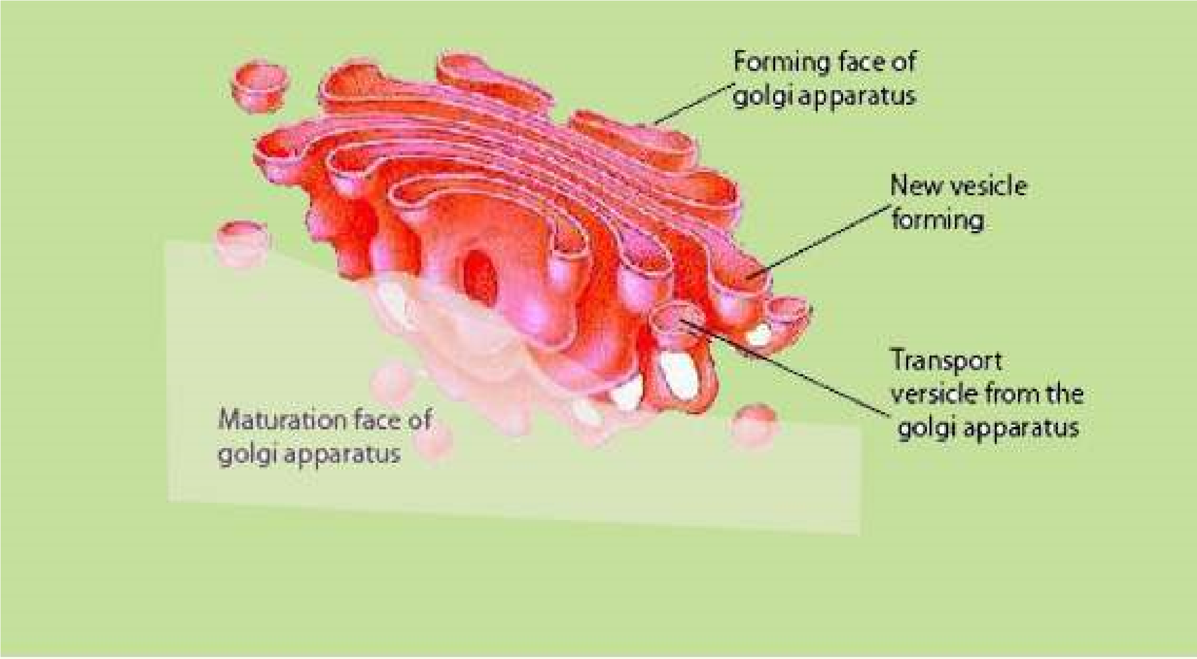

*Fig. 4.9 Golgi Complex*

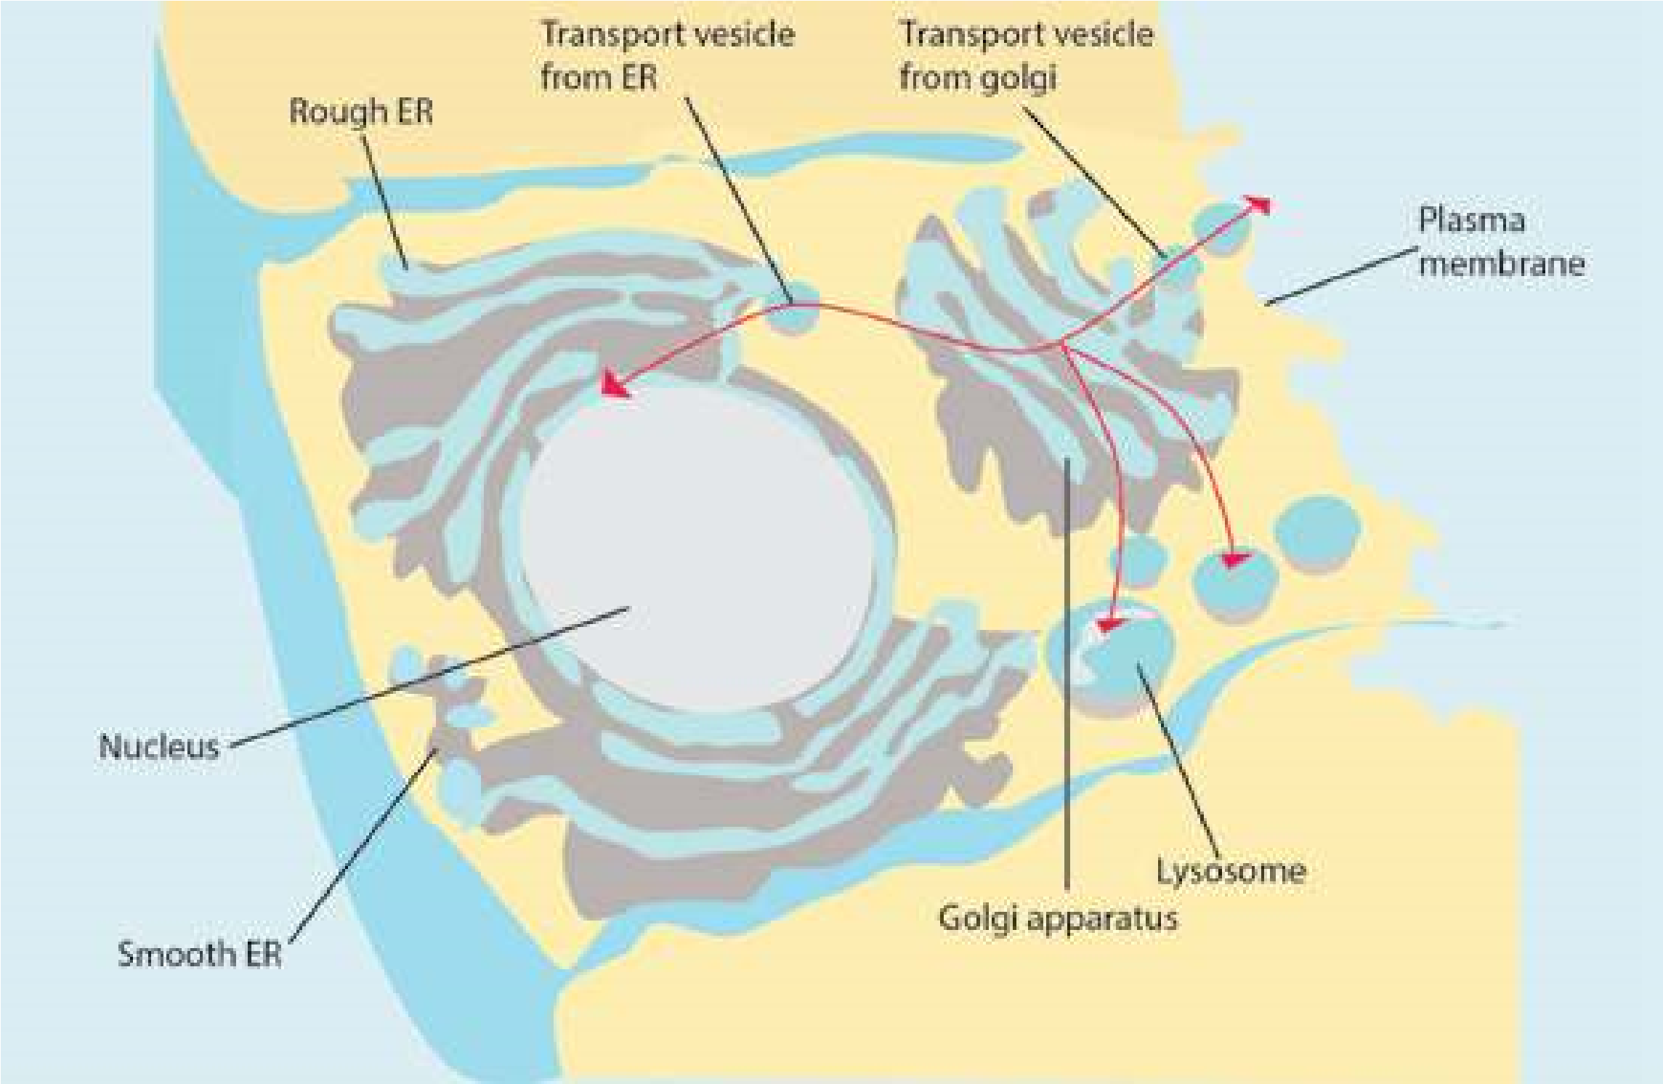

*Fig. 4.10. :This igure shows relationship of endoplasmic reticulum with Golgi Apparatus, lysosome and plasma membrane. Golgi Apparatus has two ends, Forming Face and Maturation Face. Blebs from tips of SER fuse with Golgi Apparatus cisternae at Forming Face, whereas secretory granules.*

(transport vesicles) are pinched of at the Maturation Face of Golgi Apparatus. The arrows show the direction of low of protein product systhesized on ribosomes. These proteins are converted into glycoproteins in the Golgi Apparatus.

Golgi complex is concerned with cell secretions. Secretions are products formed within the cell on ribosomes and then passed to the outside through endoplasmic reticulum and Golgi Apparatus. The secretions are converted into inished product and are packed inside membrane, before export. For example in mammals, the pancreas secretes granules containing enzymes that help in digestion. The Golgi complex has a role in formation of these granules. The proteins or enzymes which have to be transported out of the cell pass through the Golgi Apparatus. The most important function of this apparatus is to modify the proteins and lipids by adding carbohydrates and converting them into glycoproteins or glycolipids.

*Animation 4.6: Golgi Apparatus*

*Source and Credit:* [*Ameoba sisters*](http://www.amoebasisters.com/)

### Lysosomes

Lysosomes are cytoplasmic organelles and are diferent from others due to their morphology. These were isolated as a separate component for the irst time by De Duve (1949). Lysosomes (Lyso = splitting; soma = body) are found in most eukaryotic cells. Any foreign object that gains entry into the cell is immediately engulfed by the lysosome and is completely broken into simple digestible pieces. The process is known as phagocytosis (eating process of a cell). They are most abundant in those animal cells which exhibit phagocytic activity. They are bounded by a single membrane and are simple sacs rich in acid phosphatase and several other hydrolytic enzymes. These enzymes are synthesized on RER and are further processed in the Golgi apparatus. The processed enzymes are budded of as Golgi vesicles and are called as primary lysosomes (Fig.4.11). Lysosomes contain those enzymes which can digest the phagocytosed food particles.

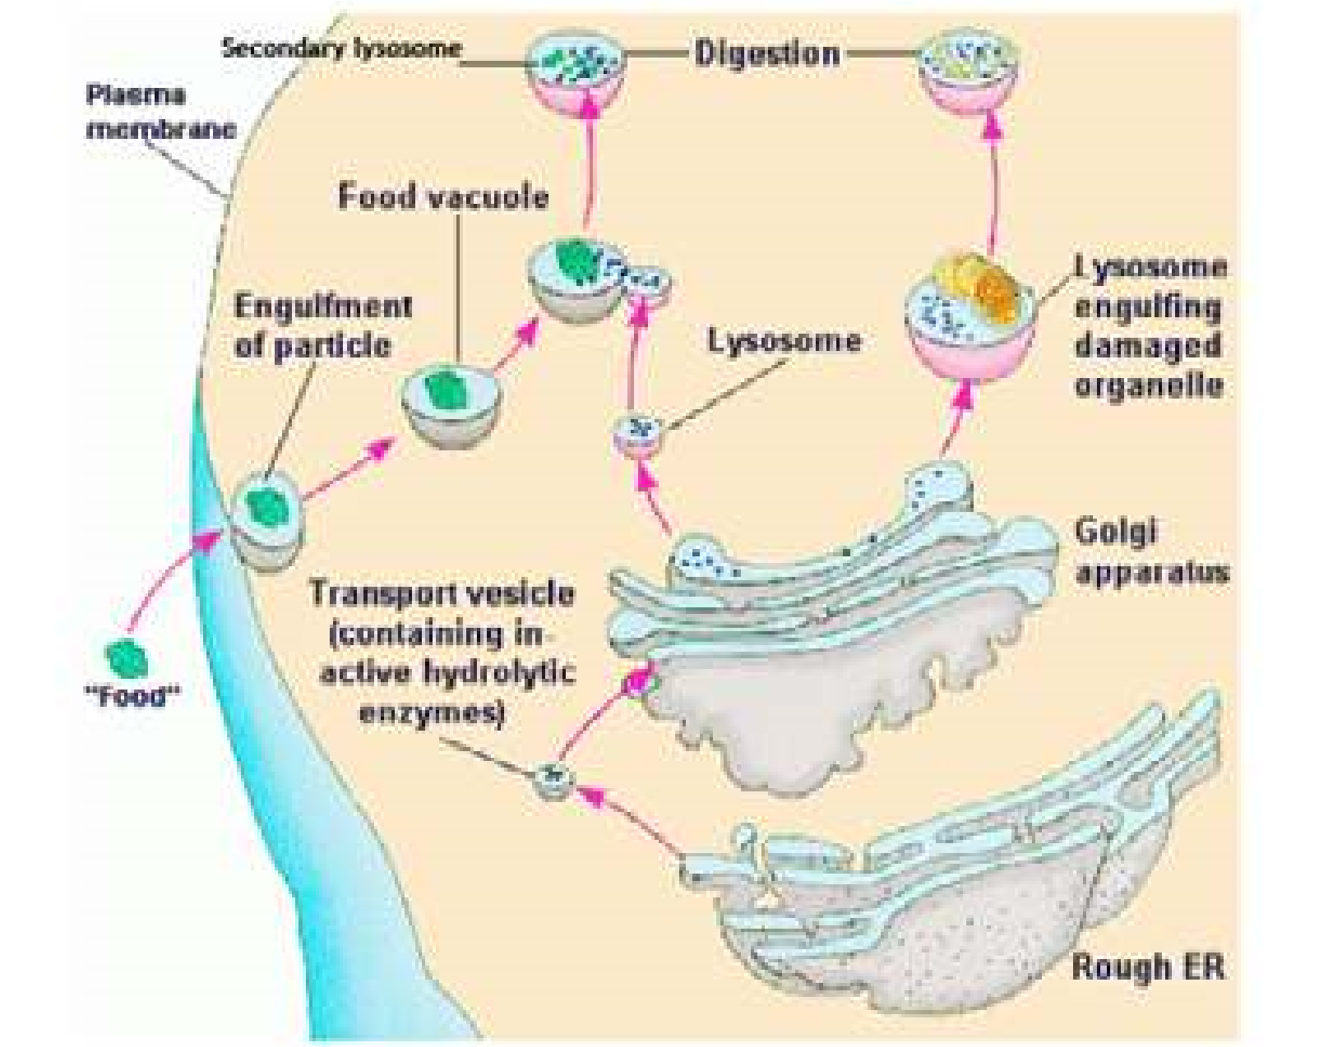

*Fig. 4.11: Lysosomes protect the cells from invading organisms or any other foreign object, (food) which are engulfed in the cell as phagocytic vacuoles. These fuse with primary lysosomes to form digestive vacuole (secondary lysosome) in which various lysosomal enzymes digest various.*

components of the vacuole. Some times, under abnormal circumstances, e.g. starvation, or as a normal physiological process the parts of the cell are engulfed by primary lysosomes and digested to generate energy. The lysosomes which eat parts of their own cell are known as autophagosomes. The digestive vacuoles and autophagosomes are also known as Secondary Lysosomes.

They are also involved in the autophagy (self eating). During this process some old, worn out parts of cell, such as old mitochondria are digested. In this way, materials of cell may be recycled and cell may be renewed. Their enzymes can also result in degeneration of cell, as may occur during some developmental processes. Lysosomes also release enzymes for extra cellular digestion.

Several congenital diseases have been found to be due to accumulation within the cell of substances such as glycogen or various glycolipids. These are also called storage diseases and are produced by a mutation that efect one of the lysosomal enzymes involved in the catabolism of a certain substance. For example, in glycogenosis type II disease, the liver and muscle appear illed with glycogen within membrane bound organelles. In this disease, an enzyme that degrades glycogen to glucose, is absent. About twenty such diseases are known these days, which are because of absence of a particular enzyme. For example Tay-Sach’s disease is because of absence of an enzyme that is involved in the catabolism of lipids. Accumulation of lipids in brain cells lead to mental retardation and even death.

*Animation 4.7: Lysosomes*

*Source and Credit:*

*Ameoba sister*

[*s*](http://www.amoebasisters.com/)

#### Peroxisome

De-Duve and coworkers isolated in 1965 particles from liver cells and other tissues which were enriched with some oxidative enzymes, such as peroxidase, catalase, glycolic acid oxidase and some other enzymes. The name peroxisome was applied because this organelle is speciically involved in the formation and decomposition of hydrogen peroxide in the cell.

These are single membrane enclosed cytoplasmic organelles found both in animal and plant cells. These are characterised by containing H202 - producing oxidases and catalase. They are approximately 0.5 nm in diameter. They have also been found in protozoa, yeast and many cell types of higher plants.

### Glyoxysomes

Plants contain an organelle, which in addition to glycolic acid oxidase and catalase also possess a number of enzymes that are not found in animal cells. These organelles, called glyoxysomes are most abundant in plant seedlings, which rely upon stored fatty acids to provide them with the energy and material to begin the formation of a new plant. One of the primary activities in these germinating seedlings is the conversion of stored fatty acids to carbohydrates. This is achieved through a cycle, glyoxylate cycle, the enzymes of which are located in the glyoxysomes.

In plants, peroxisomes play important role in both catabolic and anabolic pathways. In seeds rich in lipids such as castor bean and soyabeans, glyoxysomes are the sites for breakdown of fatty acids to succinate.

This organelle is present only during a short period in the germination of the lipid-rich seed and is absent in lipid-poor seed such as the pea.

#### Vacuoles

Although vacuoles are present both in animal and plant cells, they are particularly large and abundant in plant cells often occupying a major portion of the cell volume and forcing the remaining intracellular structures into a thin peripheral layer. These vacuoles are bounded by a single membrane and are formed by the coalescence of smaller vacuoles during the plant’s growth and development. Vacuoles serve to expand the plant cell without diluting its cytoplasm and also function as sites for the storage of water and cell products or metabolic intermediates.

The plant vacuole is the major contributor to the turgor that provides support for the individual plant cell and contributes to the rigidity of the leaves and younger parts of the plants.

*Animation 4.8: Vacuole*

*Source and Credit:* [*Ameoba sisters*](http://www.amoebasisters.com/)

### Cytoskeleton

Cytosol contains cytoskeletal fabric formed of **microtubules**, **microilaments** and **intermediate ilaments**. The main proteins that are present in cytoskeleton are tubulin (in microtubules), actin, myosin, tropomyosin and others which are also found in muscles. Several cell organelles are derived from special assemblies of microtubules, for examples cilia, lagella, basal bodies and centrioles. The movement of cyclosis and amoeboid movements are because of microilaments, whereas intermediate ilaments are involved in determination of cell shape and integration of cellular compartments (Fig. 4.2).

**Microtubules** are long, unbranched, slender tubulin protein structures. One very important function of mirotubules is their role in the assembly and disassembly of the spindle structure during mitosis.

**Microilaments** are considerably more slender cylindres made up of contractile actin protein, linked to the inner face of the plasma membrane. They are involved in internal cell motion.

**Intermediate** ilaments have diameter in between those of microtubules & microilaments. They play role in the maintenance of cell shape.

#### Centriole

*Animation 4.9: Centrioles*

*Source and Credit: ibiblio*

Animal cells, and cells of some microorganisms and lower plants contain two centrioles located near the exterior surface of the nucleus. In cross section each centriole consists of a cylindrical array of nine microtubules. However, each of the nine microtubules is further composed of three tubules (Fig. 4.12). The two centrioles are usually placed at right angle to each other. Just before a cell divides, its centrioles duplicate and one pair migrates to the opposite side of the nucleus. The spindle then forms between them. They are absent in higher plants. Centrioles play important role in the location of furrowing during cell division, and in the formation of cilia.

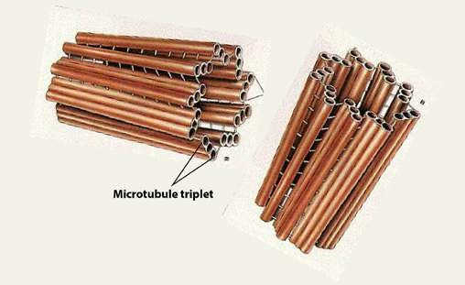

[*Fig. 4.12. Centrioles are made up of nine microtubule triplets.*](http://www.maktab.pk/unit/fsc-biology-book1-ch-4-lec-15-cytoskeleton-and-centriol/?id=365)

[**Mitochondria**](http://www.maktab.pk/unit/fsc-biology-book1-ch-4-lec-15-cytoskeleton-and-centriol/?id=365)

[Mitochondria are very important organelles of eukaryotic cells, because they are involved in the manufacture and supply of energy to the cell. They are also known as powerhouses of the cell (Fig. 4.13). Under compound microscope they appear to be vesicles, rods or ilaments. Under an electron microscope, they show complex morphology. Although their number, shape and internal structure vary widely, a mitochondrion is bound by two membranes, the outer membrane is smooth, while the inner membrane forms infoldings into the inner chamber called mitochondrial matrix. These infolds are called **cristae.** The mitochondrial membranes are similar in structure to other cell membranes. Detailed studies have shown that mitochondria also contain DNA as well as ribosomes.](http://www.maktab.pk/unit/fsc-biology-book1-ch-4-lec-15-cytoskeleton-and-centriol/?id=365)

[The presence of ribosomes and DNA indicates that some proteins are synthesized in them. It is a self replicating organelle.](http://www.maktab.pk/unit/fsc-biology-book1-ch-4-lec-15-cytoskeleton-and-centriol/?id=365)

[The inner surface of cristae in the mitochondrial matrix has small knob like structures known as F1 particles (Fig. 4.13). Mitochondrial matrix contains in it a large number of enzymes, coenzymes and organic and inorganic salts which help in several vital metabolic processes like Kreb’s cycle, aerobic](http://www.maktab.pk/unit/fsc-biology-book1-ch-4-lec-15-cytoskeleton-and-centriol/?id=365) respiration, fatty acid metabolism etc. As a result of these metabolic processes the energy extracted from the organic food is transformed into energy rich compound ATP (adenosine triphosphate), and the ATP then provides energy to the cell on demand. The size and number of mitochondria varies and depends on the physiological activity of the cell.

*Animation 4.10: Mitochondri*

[*a*](http://www.maktab.pk/unit/fsc-biology-book1-ch-4-lec-11-ribosomes/?id=365)

*Source and Credit:*

*ibibl*

[*i*](http://www.ibiblio.org/)

[*o*](http://www.ibiblio.org/)

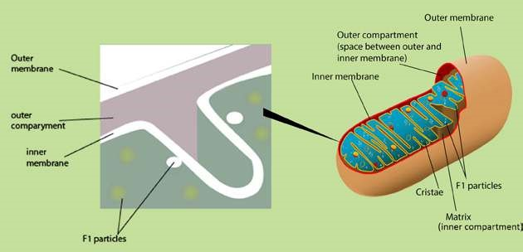

*Fig.4.13. : Diagrammatic representation of a mitochondrion cut longitudinally. The main features are shown. A crista is made of lipoprotein membrane containing diferent enzymes as well as F1 Particles embedded in it. After a special processing the inner mitochondrial membrane is ruptured and the F1 particles come out on the surface.*

Mitochondria extract energy from diferent components of food and convert it in the form of ATP. This energy is used for various cellular activities. The spent energy, which is in the form of ADP is regenerated by the mitochondria into ATP. Mitochondria is therefore described as power house of the cell.

*Animation 4.11: Mitochondrial ATP synthase*

*Source and Credit:*

*Jon Lund Stefense*

[*n*](https://plus.google.com/+JonLundSteffensen)

### Plastids

Membrane bound, mostly pigment containing bodies present in the cells are called Plastids. Plastidr are present in plant cells only.

There are three main types of plastids.

#### 1. Chloroplasts

In photosynthetic plant cells, there are membrane bound structures containing a green pigment, called chloroplasts. The green pigment is an organic compound, chlorophyll, which helps the cell to absorb light energy and utilize it to manufacture food. Chlorophyll molecule resembles the haem group of haemoglobin, a protein used in the transport of oxygen. The main diference between these two molecules is that chlorophyll has Mg++ while haem has Fe++ as the central atom.

Chloroplasts vary in their shape and size with a diameter of about 4-6 nm. Under light microscope they appear to be heterogeneous structures with small granules known as **grana** embedded in the matrix. Under electron microscope, a chloroplast shows three main components, the envelope, the stroma and the thylakoid. The envelope is formed by a double membrane, while stroma covers most of the volume of the chloroplast. Stroma is a luid which surrounds the thylakoids. It contains proteins, some ribosomes and a small circular DNA. It is in this part of the chloroplast where CO2 is ixed to manufacture sugars. Some proteins are also synthesized in this part. Thylakoids are the lattened vesicles which arrange themselves to form grana and intergrana. A granum appears to be a pile of thylakoids stacked on each other like coins. On an average, there are 50 or more thylakoids piled to form one granum. On the layers of thylakoids chlorophyll molecules are arranged and that is why granum appears to be green (Fig.4.14). Each granum is interconnected with others by the non-green part called intergranum. Membranes of the grana are sites where sun light energy is trapped and where ATP is formed. Chloroplasts are self-replicating organelles.

#### 2. Chromoplasts

They impart colours to the plants other than green. They are present in the petals of the lower and in the ripened fruit. They help in pollination and dispersal of seeds.

#### 3. Leucoplasts

They are colourless. They are triangular, tubular or of some other shape. They are found in the underground parts of the plant and store food.

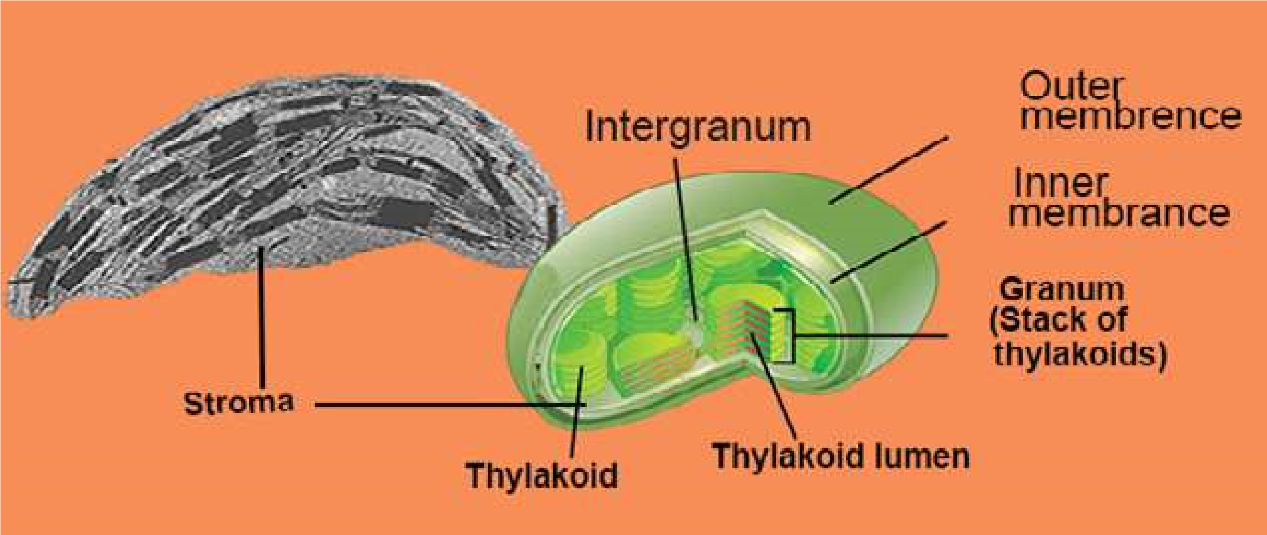

*Fig. 4.14: Diagram of chloroplast showing the main structural components.*

## NUCLEUS

Presence of cell nucleus was reported in 1831 by Robert Brown. Its early discovery was undoubtedly due to its prominence in many cells, where it stands out as slightly darker than the surrounding cytoplasm. It controls the life and activities of the cell. In animal cells, it generally occupies the central space, while in the case of plant cells it is pushed towards periphery due to the presence of a large vacuole. Nucleus may be irregular or spherical in shape. Generally, the cells have one nucleus and are called **mononucleate**. On the other hand, the cells with two nuclei are binucleate and with more than two as multinucleate.

Nucleus is only visible when the cell is in non-dividing stage. It contains **chromatin network** and soluble sap called **nucleoplasm**. In dividing cells, the nucleus disappears and the chromatin material in it is replaced by chromosomes. The heredity material is in the form of chromosomes, which controls all the activities of the cell. DNA, RNA and proteins including enzymes form the chemical composition of the nucleus. Nucleus consists of nuclear membrane, nucleoli, nucleoplasm and chromosomes.

### Nuclear Membrane

Nucleus is surrounded by a nuclear membrane which separates the nuclear material from the cytoplasm. The nuclear membrane is actually a nuclear envelope composed of two membranes. The outer membrane is at places continuous with the endoplasmic reticulum, while the inner membrane encloses the nuclear content. The outer and the inner membranes are continuous at certain points resulting in the formation of pores, the **nuclear pores**. The **nuclear pores** allow the exchange of materials between the nucleus and the cytoplasm. The number of nuclear pores is highly variable. The undiferentiated cells (such as eggs) have numerous pores (about 30,000 per nucleus), whereas diferentiated cells such as erythrbcytes have only 3 or 4 pores/nucleus. Each pore has a deinite structure which controls the traic of substances passing through them (igs.

4.7, 4.10 and 4.16).

### Nucleolus

It is a darkly stained body within the nucleus, and is without any membranous boundary to separate it from the rest of the nuclear material. There may be one or more nucleoli in the nucleus. The ribosomal RNA (rRNA) is synthesized and stored in the nucleolus. It is composed of two regions, the peripheral granular area composed of precursors of ribosomal subunits and the central ibrill area consisting of large molecular weight RNA and rDNA. It is the nucleolus where ribosomes are assembled and are then exported to the cytoplasm via nuclear pores.

*Animation 4.12: Nucleus*

*Source and Credit:*

*gifsou*

[*p*](http://gifsoup.com/)

*Animation 4.13: Nucleus*

*Source and Credit:*

*ibibli*

[*o*](https://www.ibiblio.org/virtualcell/textbook/chapter3/nuc.htm)

### Chromosomes

Nucleus is often deeply stained with basic dyes because of the chromatin material. During cell division chromatin material is converted into darkly stained thread like structures known are chromosomes. Under a compound microscope, chromosomes appear to be made of arms and centromeres. Centromere is the place on the chromosome where spindle ibres are attached during cell division. Each chromosome consists of two identical chromatids at the beginning of cell division (chromatid is exact replica of the chromosome) which are held together at centromere (Fig.4.15).

A chromosome is composed of DNA and proteins. All the information necessary to control the activities of the cell is located on the chromosomes in the form of genes, which are transferred from one generation to the other. The number of chromosomes in all individuals of the same species remains constant generation after generation. In man, each cell contains 46 chromosomes, frog cell has 26 and chimpanzee has 48 chromosomes. There are 8 chromosoms in the fruit ly, *Drosophila melanogaster*, 16 chromosomes in onion, 48 in potato, and 14 in garden pea. The number of chromosomes in normal body cells is diploid (2n), whereas haploid chromosome number (n) is present in germ cells, e.g human sperms and eggs have 23, while those of *Drosophila* have 4 chromosomes.

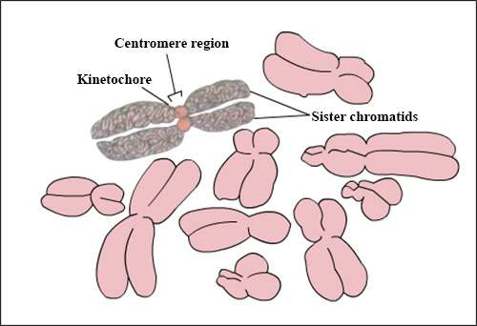

*Fig.4.15. : Structure of chromosome and its shape.*

*Fig. 4.16 Structure of nucleus*

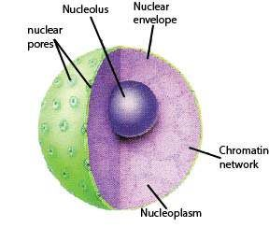

## PROKARYOTIC AND EUKARYOTIC CELL

Biologists have divided cells into two types: prokaryotic and eukaryotic. The diferences between these two types of cells are mainly based upon the structure of their nuclei. Eukaryotes have a very well deined nucleus, in which nuclear material (chromosomes or DNA) is enclosed in double nuclear membrane. In prokaryotic cells, however the genetic material (DNA) is without any nuclear membrane covering and is directly submerged in the cytoplasm. Organisms possessing prokaryotic cells are called Prokaryotes and those possessing eukaryotic cells are called Eukaryotes. Prokaryotes include bacteria and blue green algae. Eukaryotes include all other unicellular or multicellular organisms such as animals, plants, fungi and protista.

Diagrams of prokaryotic and eukaryotic cells are given in Fig 4.2, 4.3, and 4.17. Prokaryotic cells generally lack many of the membrane bounded structures found in eukaryotic cells. For example, mitochondria, endoplasmic reticulum, chloroplasts and Golgi apparatus are absent in prokaryotic cells. Since there is no nuclear membrane, a prokaryotic cell has no distinct nucleus and its DNA molecule is directly suspended in cytoplasm. Prokaryotes have small sized ribosomes 70S compared to eukaryotes 80S. In prokaryotes mitosis is missing and the cell divides by binary ission. Because of their simpler structure, it was widely accepted for a long time that prokaryotic cells represent a more primitive stage of evolution than eukaryotic cells. Perhaps the most distinctive feature of the prokaryotic cell is its cell wall, composed of polysaccharide chains bound covalently to shorter chains of amino acids forming peptidoglycan or murein. The entire cell wall is often regarded as a single huge molecule or molecular complex called sacculus The cell wall of plants is generally made up of cellulose and is diferently structured than that of a bacterium.

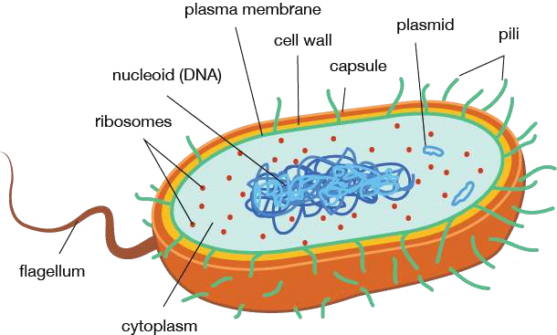

*Fig. 4-17. Generalized Prokaryotic cell.*

*Animation 4.14: Prokaryote vs. Eukaryote*

*Source and Credit:*

*Ameoba sister*

[*s*](http://www.amoebasisters.com/)

### Exercise

**Q.1. Fill in the blanks:**

(i) In eukaryotic cell chromatin material is bounded b y ------------- (ii) A group of ribosomes attached to mRNA is known as —------------

1. -------------- is the place on chromosomes where spindle ibres are attached during cell division.
2. The endoplasmic reticulum with attached ribosomes is known as ------------ (v) The soluble part of the cytoplasm is called.

**Q.2. Write whether the statement is ‘true’ or ‘false’ and write the correct statement if it is false.**

1. Cell membrane is present in all eukaryotic cells.
2. Chloroplast and mitochondria do not have hereditary material.
3. Centriole is involved in cell secretions.
4. Sometimes many ribosomes get attached to the same stretch of mRNA forming a structure called the cytosome.
5. Mitochondria are very important organelles of the eukaryotic cells.**Q.3. Short Questions.**

i. Describe various movements involved in the transport of materials across the cell membrane. ii. State various structural modiications in a cell involved in secretions. iii. List the processes blocked by mitochondrial failure in a cell. iv. What will happen if a chromosome loses its centromere?

V. How does autophagy help in converting a tadpole larva into an adult amphibian?

vi. Is there any similarity between bacterial and plant cell wall?

**Q.4. Extensive Questions.**

(i) Compare structure and function of chloroplasts and mitochondria. (ii) State ‘Cell Theory’ and discuss its emergence.

(iii) Write notes on :

(a) Cytoskeleton (b) Peroxisomes & Glyoxysomes (v) What might happen if some lysosomal enzymes are absent?

Explain with examples.